**EE311 DIGITAL SYSTEM DESIGN - ASSIGNMENT 3**

**Submission due: 16th March 2020**

1. Find a minimum row PLA to implement the following three functions:

f(A, B, C,D) = ∑m(3,6,7,11,15)

g(A, B, C,D) = ∑m(1,3,4,7,9,13)

h(A, B, C,D) = ∑m(4,6,8,10,11,12,14,15)

Use K maps to find common terms. Give the logic equations with common terms underlined, the PLA table and also a PLA diagram.

1. Find a minimum row PLA table to implement the following sets of functions
2. f1(A,B,C,D) = ∑m(0,2,3,6,7,8,9,11,13)

f2(A,B,C,D) = ∑m(3,7,8, 9,13)

f3(A,B,C,D) = ∑m(0,2,4,6,8,12,13)

1. f1(A,B,C,D) = cd + ad + a’bc’d’

f2(A,B,C,D) = bc’d’ + ac’ + ad’

1. List the PLA and PAL programming table for BCD – Excess 3 code converter. (Hint: Obtain the simplified Boolean functions of BCD – excess 3 code converter first).
2. The following is a truth table of a three input, four output combinational circuit. Tabulate the PAL programming table and draw the PAL diagram.

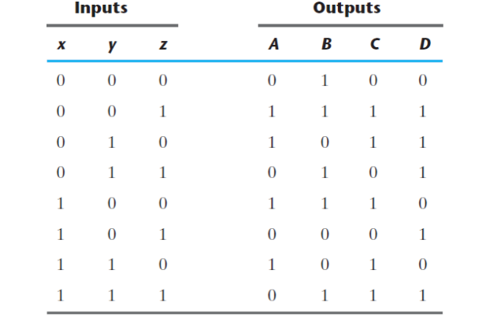

1. How to implement a full subtracter using PAL?